MOHITE CONSULTANCY SERVICES
(Service Tax Registration No: ABDFM3622NSD003)

78, Shivshakti Sangh, New Sambhaji Nagar, Near Karnatak School, Ghatla, Chembur, Mumbai -400071.

Website : MohiteTax.in E-mail : admin@MohiteTax.in Mobile : 9619156719
Bill No.: 04-03/2017 Date: 09/03/2017

To
Mr. Amol Ananda Chavan,
Manager, Shree Om Sai Co-Op Credit Society,
4 AC 1247, Near The National Sarvodaya High School, Opp.Dudheswar Mandir,
C.G.Gidwani Marg, Chembur Colony, Chembur East, Mumbai – 400074.
Particulars | Amount (Rs.)
OUR FEES FOR PROFESSIONAL SERVICES RENDERED IN RESPECT OF:  - Submission of Compliance on the efiling website wr.t. queries raised by CPC.  - Submission of Compliance on the efiling website w.r.t cash transactions carried out during demonetization period.  - Preparation of Income Tax Computation for F.Y. 2014-15.  - Efiling of the Income Tax Return on the Income Tax efiling website for F.Y. 2014-15.  Bank Name : Mumbai District Central Co-Op Bank Ltd.  Branch : Chembur, Mumbai  IFSC Code : MDCB0680009  MICR Code : 400068009  Account No. : 00091101000554  Account Type : Current | 1000.00  1000.00  3000.00  3000.00
TOTAL | 8000.00
Rupees: Eight Thousand Only.

For M/s Mohite Consultancy Services

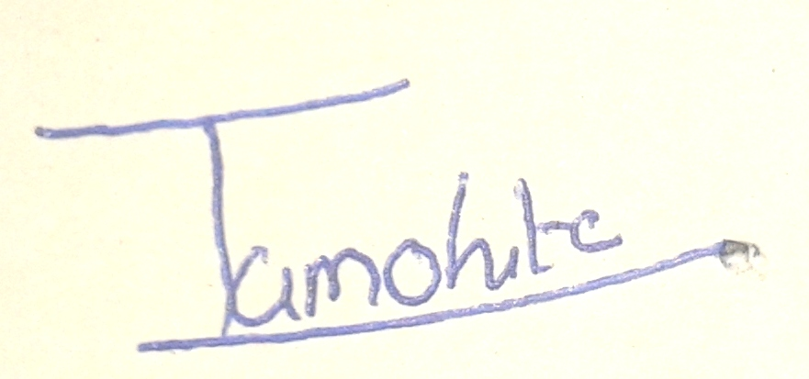

Authorized Signatory

